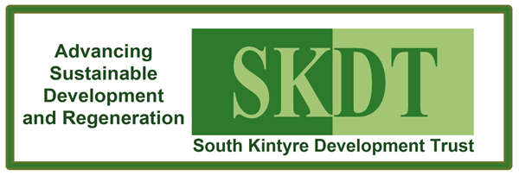

Annual General Meeting of South Kintyre Development Trust

AGM AGENDA
- Opening Remarks/Welcome
- Apologies
- Minutes of previous AGM held on 7 November 2018 (copies available from the Town Hall website at www.skdt.org)
- Directors report
- Adoption of Trustees Reports for 2018-19 and 2019-20
- Trust Manager’s Report
- Presentation and adoption of Accounts for year ended 31st March 2019 and 31st March 2020
- The fixing of the annual subscription. [No change is proposed, by the directors, to the current annual subscription of £nil]
- Election of Directors
Retiring by rotation and willing to be re-elected: Felicity Kelly, Sandra Spence
Retiring as co-opted Director in line with Articles 35-35.4 and willing to be elected: Ian Kendrick
No other nominations were received for election at time of issue: in line with Article 33.6
- Closing Remarks

